CIS Project screen shots

Home Page

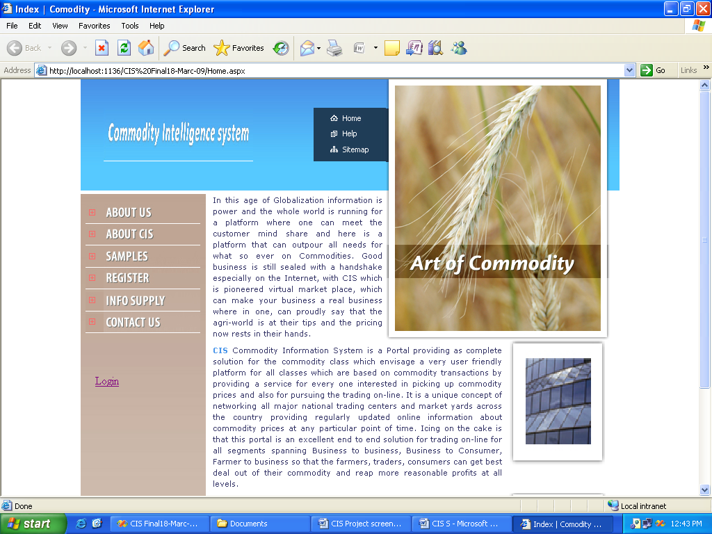

Customer Registration

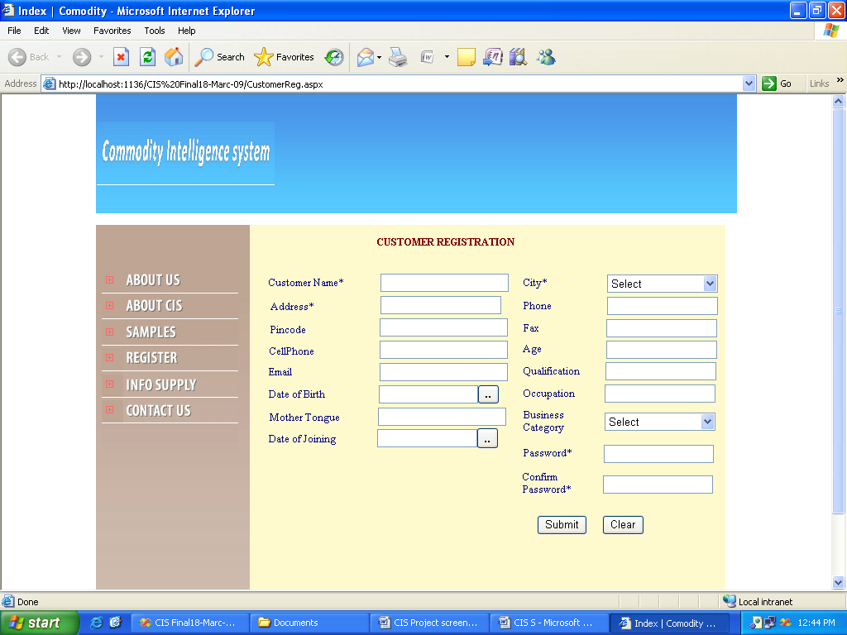

INFO SUPPLIER REGISTRATION SCREEN

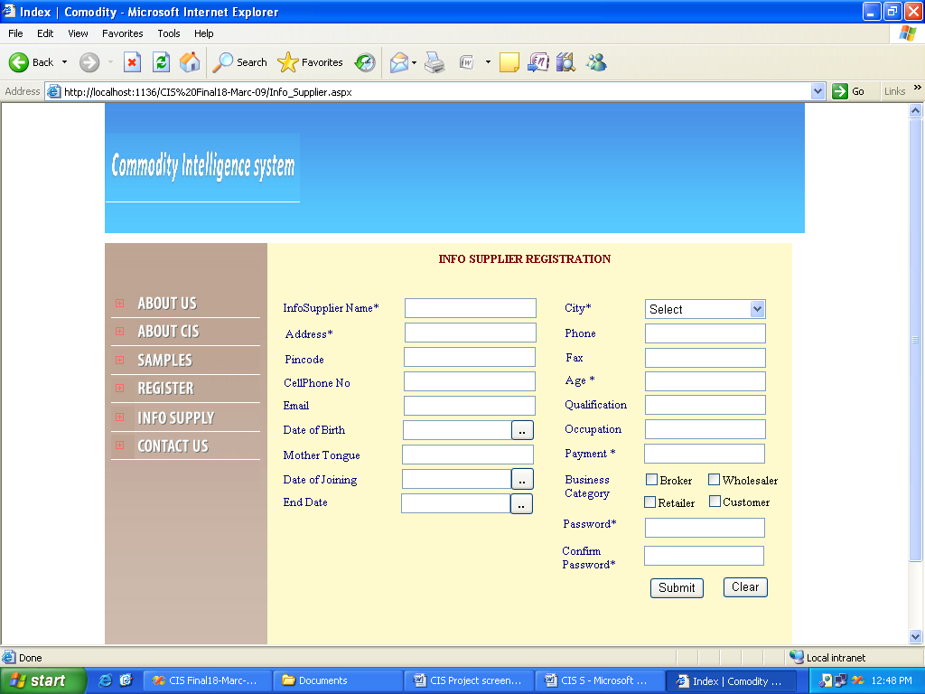

LOGIN SCREEN

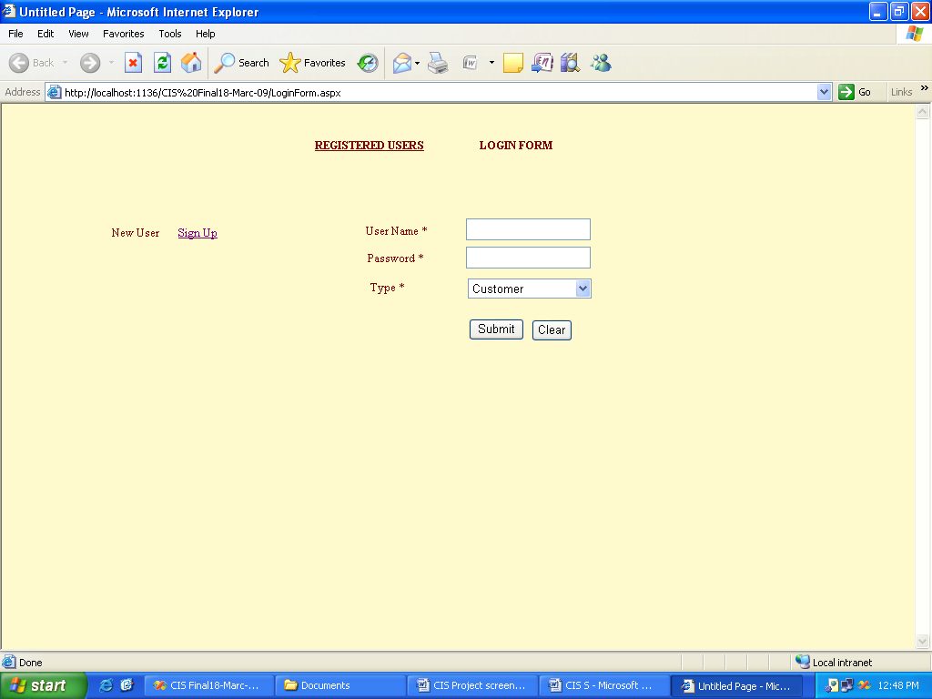

ADMIN HOME PAGE

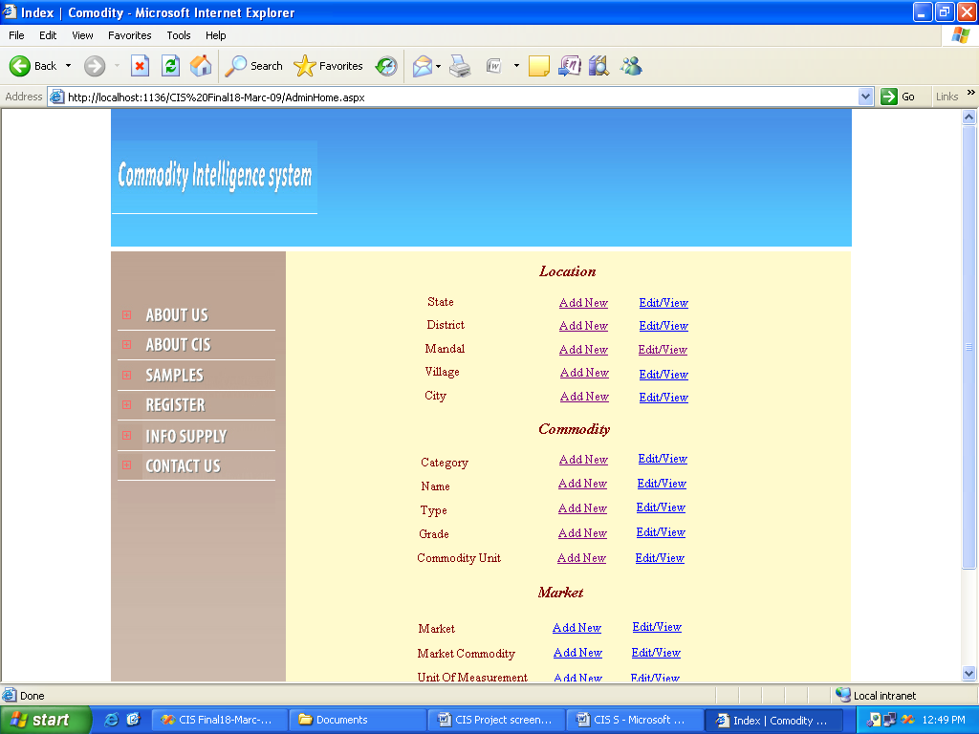

ADMIN HOME PAGE

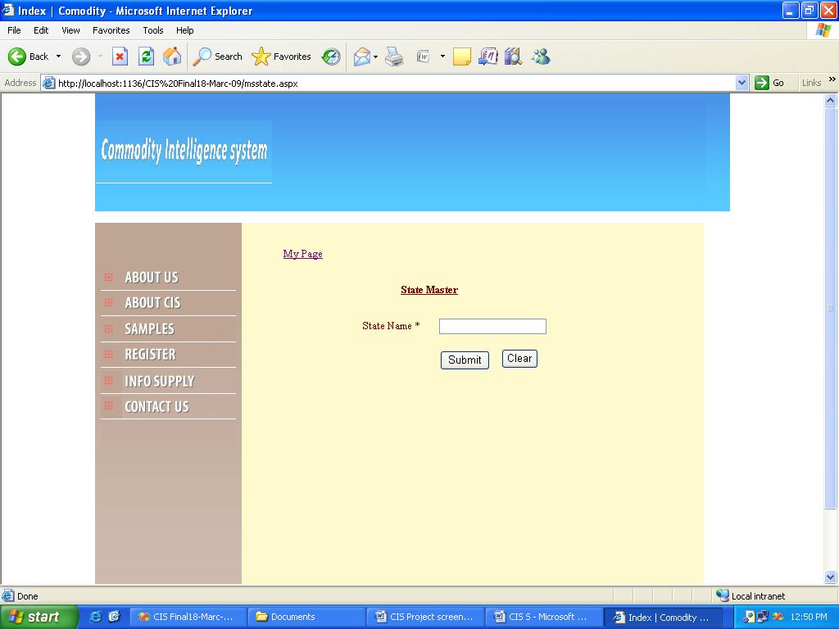

LOCATION ---- MADAL ENTRY SCREEN

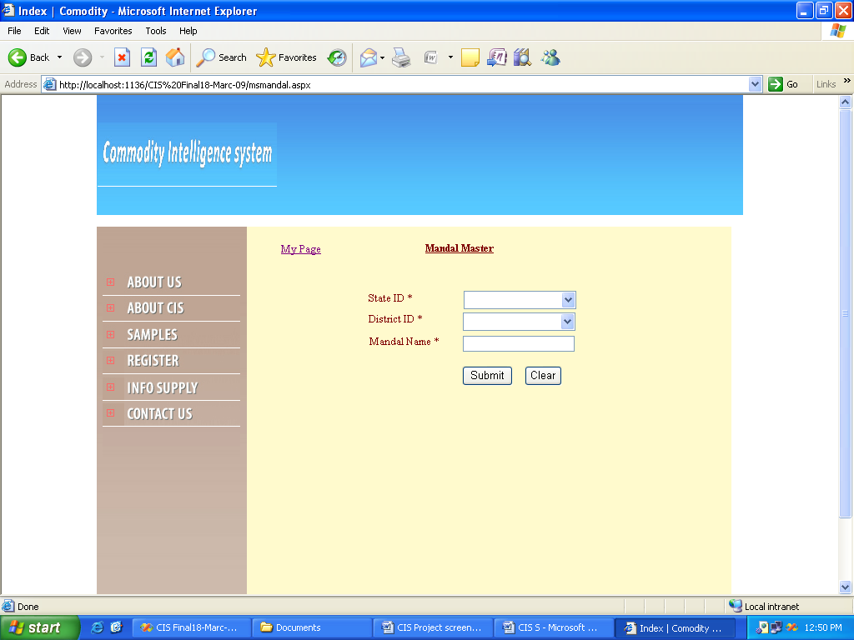

LOCATION – VILLAGE ENTRY SCREEN

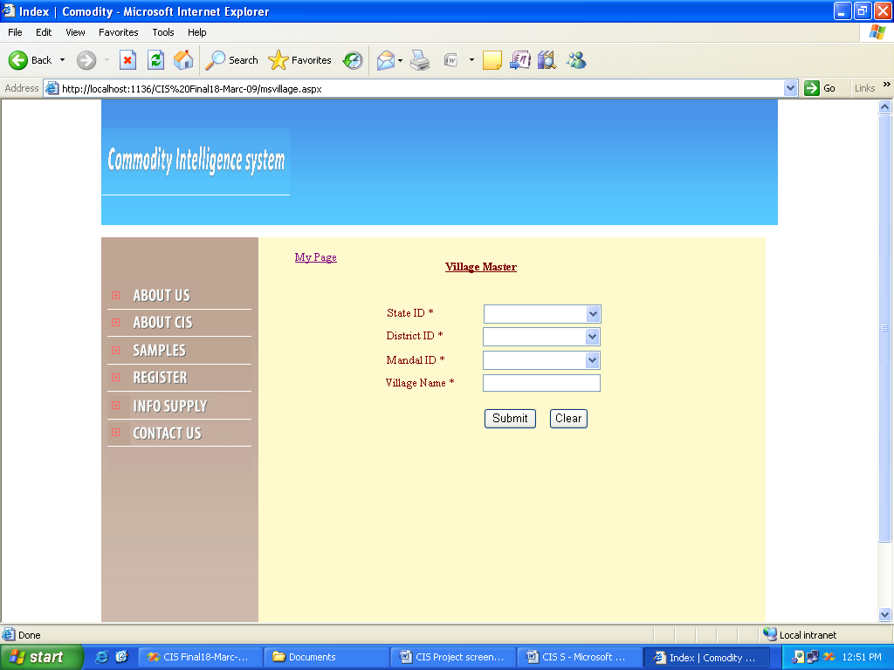

COMMODITY – CATEGORY ENTRY SCREEN

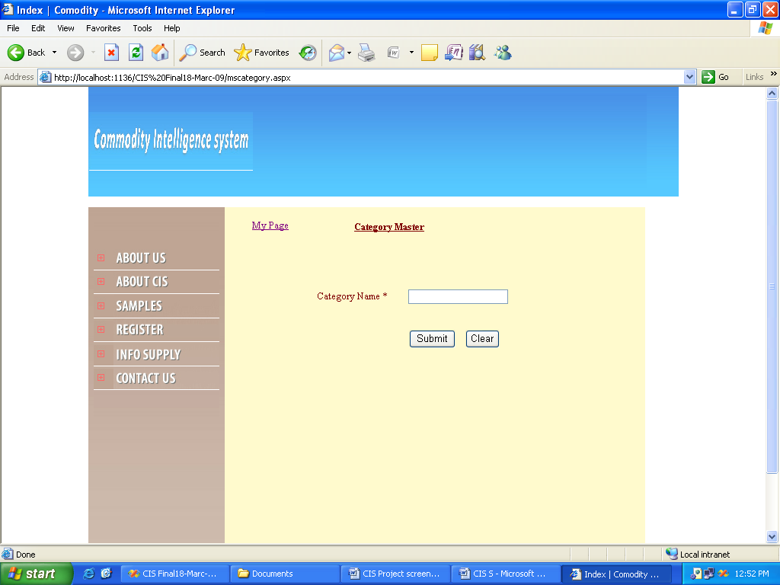

COMMODITY – TYPE ENTRY SCREEN

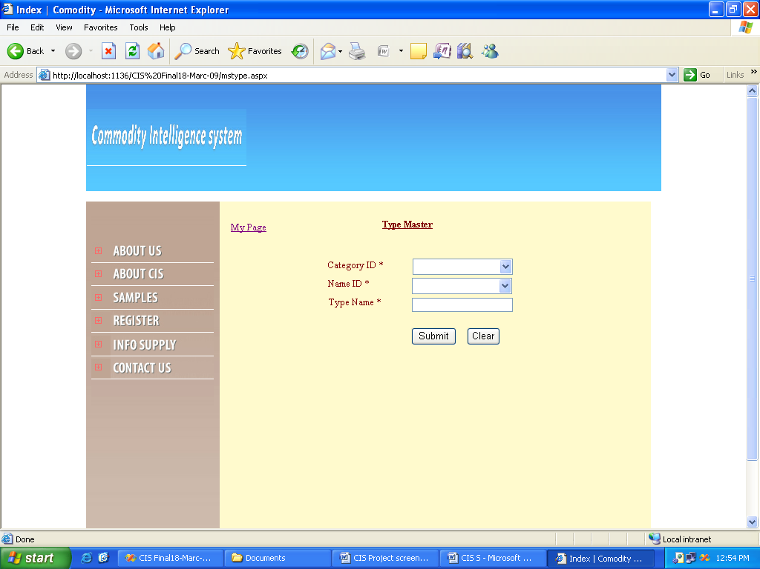

COMMODITY – GRADE ENTRY SCREEN

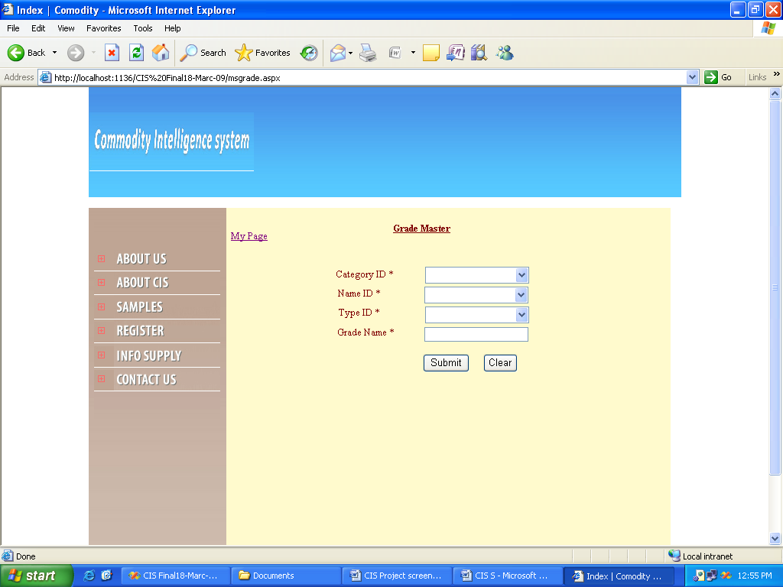

COMMODITY – UNIT ENTRY SCREEN

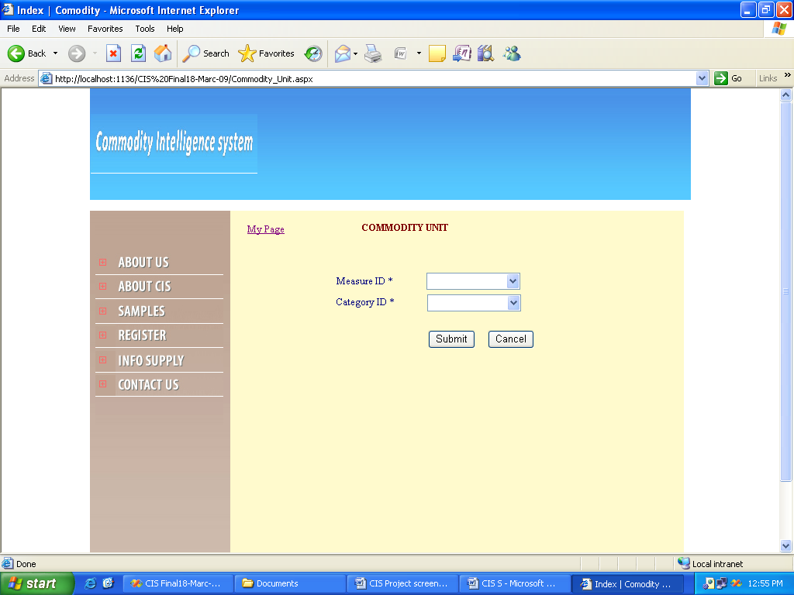

MARKET ENTRY SCREEN

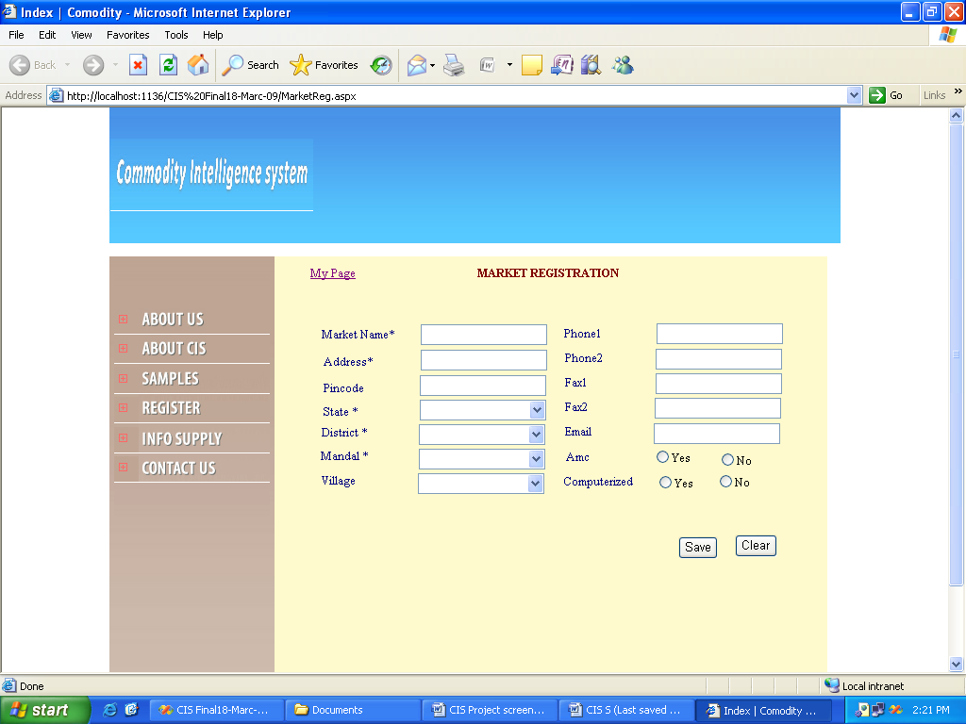

MARKET COMMODITY

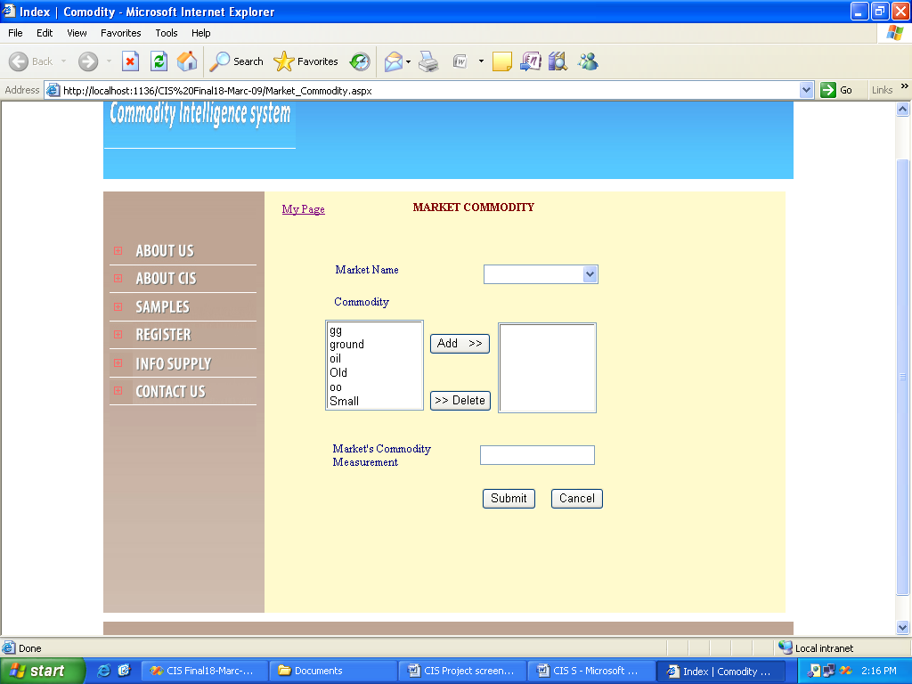

UNIT OF MEASUREMENT ENTRY SCREEN

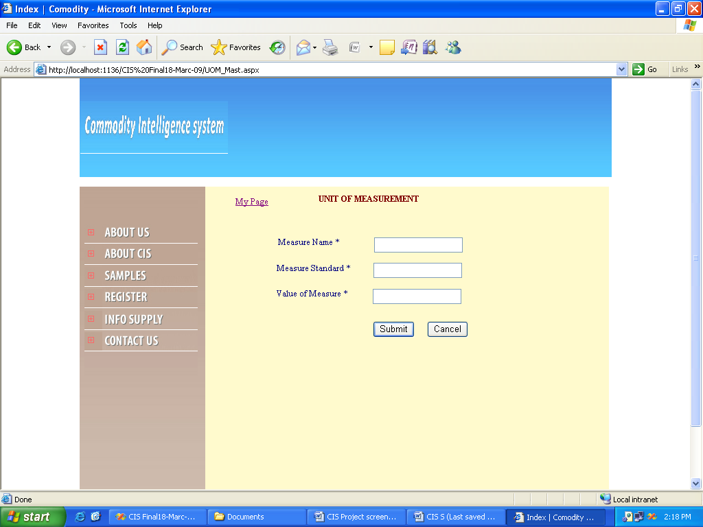

CIS REPORTS

